E-commers Customer Service Satisfaction

Name: Ali Ahmed Ali

**Topic**

|  |  |  |  |
| --- | --- | --- | --- |
|  | **Topic** | **From Page** | **To** |
| 1. | **Introduction:** | 3 | 3 |
|  | * PROBLEM STATEMENT | 3 | 3 |
|  | * OBJECTIVES | 3 | 3 |
| 2. | **Cleaning:** | 4 | 10 |
|  | * understanding data | 4 | 5 |
|  | * Removing null and drop columns | 5 | 7 |
|  | * Change types and rename | 7 | 9 |
|  | * Add now column and detail | 9 | 10 |
| 3. | **Excel Analysis:** | 11 | 18 |
| 4. | **present graphs:** | 19 | 27 |
| 5. | **conclusion:** | 28 | 28 |
| 6. | **Recommendation:** | 28 | 28 |

1.Introduction: -

I chose data from the site (Kaggle) the link:

<https://www.kaggle.com/datasets/ddosad/ecommerce-customer-service-satisfaction>

the Topic Title is (eCommerce Customer Service Satisfaction) for shop sit his name is shopzilla.

**Note: original information has been obscured, and the dataset has been fabricated to ensure that the original details are hidden.**

PROBLEM STATEMENT:

Shopzilla, a prominent online retailer, is keen to maintain its reputation for exceptional customer service and enhance its understanding of consumer behavior. To achieve this, Shopzilla has collected a month’s worth of consumer satisfaction ratings. The goal is to understand consumer behavior, forecast customer satisfaction, and evaluate customer service effectiveness.

OBJECTIVES:

1. How effective are managers at managing communication channels?
2. Do the prices of products affect customer service on managers?
3. How many orders for each Customer Rating do they get?
4. What is the Customer Rating of the problems that take the longest time to solving problems?
5. What is the Customer Rating of the sub problem for the top 3 problems that take the longest time?
6. How does the scheduling of shift periods impact employees?
7. The impact of the tenure bucket (employees insurance) on employees?
8. How many employees for every Customer Rating in employee shift?
9. How many employees for every Customer Rating in tenure bucket (employees insurance)?

item use:

* Use Python to cleaning
* Excel to analyst and present

**2.Cleaning**: -

**2.1) understanding data: -**

In cleaning I use python, to knowing about data and drop same of column that I don’t need to analytics, also the important think remove null from data and change same of thinks.

So first, I use:

I read a csv table which is (Customer_support_data.csv), also I use code:

pip install sweetviz

analyze_report = sv.analyze(customer)

analyze_report.show_html('report.html')

To open page for information about data to I know what data has.

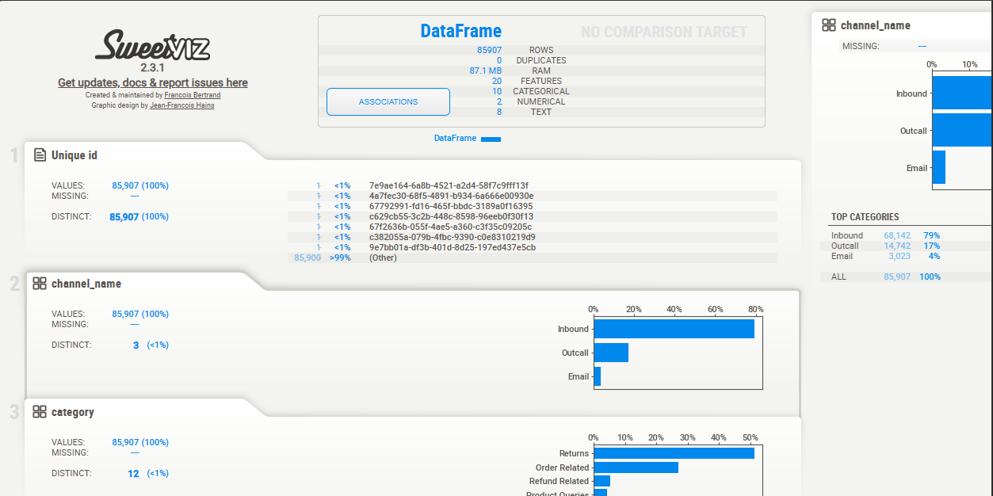

Then I use codes to get a details for data like (cu.shape) to know how many (column,row) in data, then (cu.dtypes) to show the types of column if integer or objects ect.. and if I need to change and the name of columns data has.

**2.2) Removing null and drop columns: -**

Then I use code (cu.head() ) to see the data and information has, so what I fond is column

| (ssue_reported at, | issue_responded, | Survey_response_Date) |
| --- | --- | --- |

Have a same date day so I will drop columns (ssue_reported at , Survey_response_Date)

Also drop column (Customer Remarks), because It is comment from customer

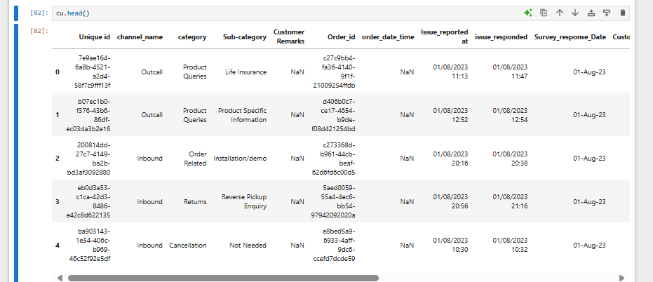

Then code (cu.isna().sum()) to show which column has a null and how many, and code ((cu.isna().sum()/cu.shape[0])*100) to showing by percentage(%)

Then I remove the null form column (order_date_time) and I drop the column I don’t need.

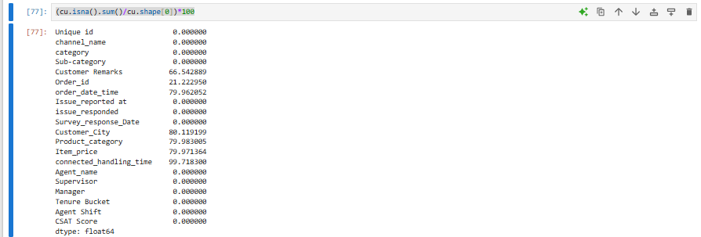

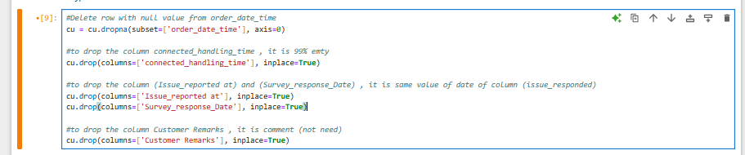

After that a use (cu.isna().sum()) code to see Again if data has a null or not and where

**2.3) Change types and rename: -**

Then I see how many columns and row I have (.shape), also the (.dtype) to see What columns should change its type and What columns should change a name and I change the name of column to lowercase to be easy to call them.

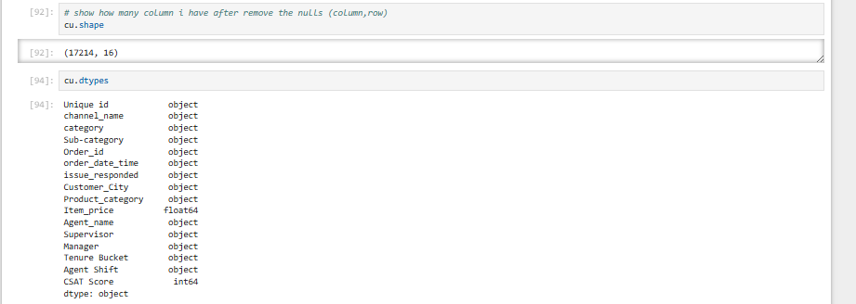

Also I found the columns (order_date_time) and (issue_responded) are object so should be change to (datetime), also that (agent name) is same of employee name.

So, I will rename column (Agent name) to (employee name) and the (Agent shift) to (employee shift)

By use code (.head) that will see s problems name as (category) and sub_problems Is (sub_category) and there are product_category.

So I will rename the (category) to the (problems) and (sub_category) to sub_problems to can we see the difference between those 3 columns.

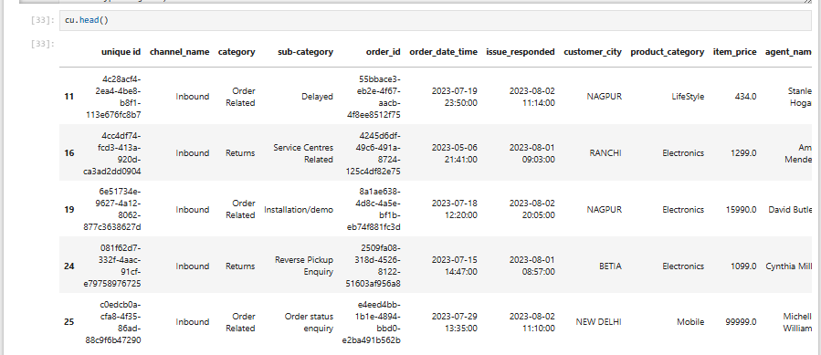

**2.4) Add now column and detail**: -

by use code(.hard) and (cu['item_price']) I can see a column 'item_price' don’t have a “$” because the price is dollars, so should be add $ before the number of price.

After that I will add a now column for age of time by days

**cu['age_daytime'] = (cu['issue_responded'] - cu['order_date_time']).dt.days**

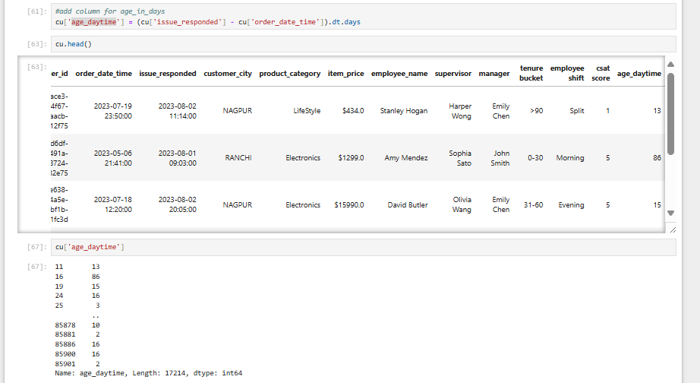

Update to csv



**Note:** Update the cleaning to the excel name: (Customer_support_datal1.csv) then I code it to other excel folder name: Customer analysis to analysis, because the csv folder don’t save the change it and not save the now thing that you donning on it, only for save tables.

3.Excel Analysis: -

I will use a excel in analysis, by solving the Objectives, the data clean in excel name: (Customer analysis)

OBJECTIVES:

1. How effective are managers at managing communication channels?
2. Do the prices of products affect customer service on managers?
3. How many orders for each Customer Rating do they get?
4. What is the rate of the problems that take the longest time to solving problems?
5. What is the Customer Rating of the sub problem for the top 3 problems that take the longest time?
6. How does the scheduling of shift periods impact employees?
7. The impact of the tenure bucket (employees insurance) on employees?
8. How many employees for every Customer Rating in employee shift?
9. How many employees for every Customer Rating in tenure bucket (employees insurance)?

**3.1) How effective are managers at managing communication channels?**

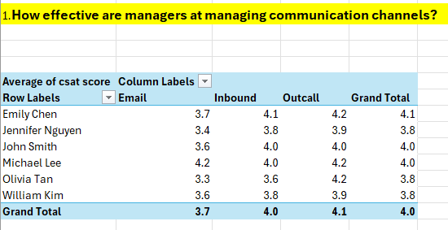

In first objective: How effective are managers at managing communication channels?

we can see a Customer Rating for manager in each channel name

all managers have a higher Customer Rating in (Outcall) and in (Email) is lower than others.

Here the channel (Email) that take lower Customer Rating, I can say that because the answer of problem Email tack longer time, so for this we need more details in problems issue in customer serves.

**3.2) Do the prices of products affect customer service on managers?**

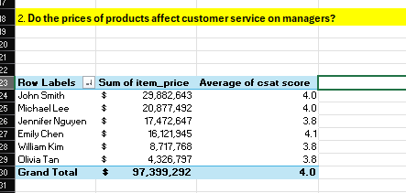

The objective: Do the prices of products affect customer service on managers?

There are sum of (item_price), (Customer Rating) and we can filter by problem name

That to see if the price of products and problems can affect in the Customer Rating.

The Customer Rating they are almost 4 Customer Rating, so the price is not affected in the serves Customer Rating.

And we can see (John Smith) has a higher price, and (Michael Lee) came in second level, but all managers are almost same Customer Rating, for this objective I can’t tack it because there are same and the problem that is with employee not with the mangers.

**3.3) How many orders for each Customer Rating do they get?**

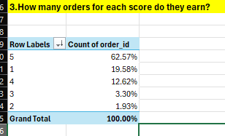

The objective: How many orders for each Customer Rating do they get?

Here 62.57% orders get 5 Customer Rating, and it is the highest number of orders.

But in same time we have 19.58% get 1 Customer Rating.

**3.4) What is the Customer Rating of the problems that take the longest time to solving problems?**

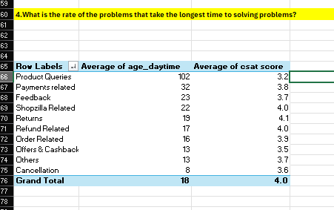

The objective: What is the rate of the problems that take the longest time to solving problems?

Here the problems name and the age of time also the Customer Rating for the problems.

What we see is there are problem (Product Queries) that tack more than (100 days) to solve also the Customer Rating is 3.2 is lower than others’ problems.

Then problem (Payments related) with (32 days) and (3.8) Customer Rating

Then problem (Feedback) with (23 days) and (3.7) Customer Rating

So those problems are top 3 problems that tack a longer time to solving issue

So, for next object I will tack top 3 problems, and I will see how many days for (sub_problems) and less Customer Rating for employees, to more details.

**3.5) What is the Customer Rating of the sub problem for the top 3 problems that take the longest time?**

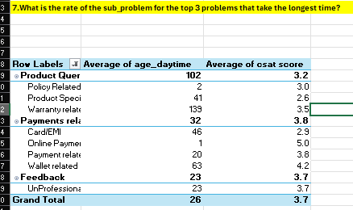

The objective: What is the rate of the sub_problem for the top 3 problems that take the longest time?

Now we show the (sub_problems) for the top 3 problems that take time, SO in problem (Product Queries) the Warranty related is take highest time (139 Days) that others sub_problems

Also, in the second level (Payments related) the wallet related with (63 days)

**3.6) How does the scheduling of shift periods impact employees?**

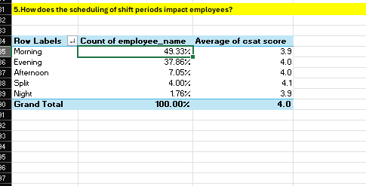

The objective: How does the scheduling of shift periods impact employees?

here the shift for the employee and percentages of how many employees work in every shift.

So here 49% of employees that work in morning and that get 3.9 Customer Rating

In second level 37% of employees work in evening and get 4.0 Customer Rating

But that the Customer Rating is almost equal to 4. Because that we won’t more details for every shite

For example, 4 employees get less Customer Rating.

**3.7) The impact of the tenure bucket (employees insurance) on employees?**

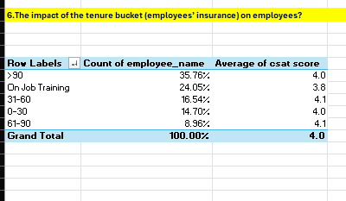

The objective: The impact of the tenure bucket (employees’ insurance) on employees?

Here we but the tenure buckets and percentage

Here we can see the tenure bucket (employees’ insurance), and there are 5 types of it and higher one is (>90) day also that the less core is 3.8 for (on job training), but We would like more details to know what is the appropriate tenure bucket for employees?

**3.8)** **How many employees for every Customer Rating in employee shift?**

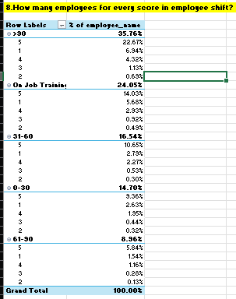

The objective: How many employees for every Customer Rating in employee shift?

Here shows the Customer Rating for percentage of employee’s name for ever shift.

We can see the morning and evening shifts have a higher rate in Customer Rating 5 and others shift is lower that becomes the employees work more in the shifts (morning and evening)

**3.9) How many employees for every Customer Rating in tenure bucket (employees insurance)?**

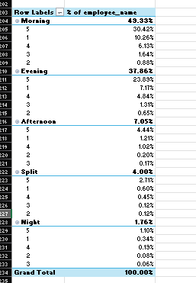

The objective: How many employees for every Customer Rating in tenure bucket (employees’ insurance)?

Here the Customer Rating for percentage of employees in each tenure bucket.

In all tenure bucket the employees take 5 stars it higher that others Customer Rating, but in tenure bucket (>90) the percentage of employees get 5 Customer Rating is (22.67%).

And tenure backet (on job training) in second level (14%) of employees that get 5 Customer Rating.

**Note:** same word in excel Is change to present:

* Average of cast score to (Customer Rating)
* Count of employee name to (% of employee)
* Count of order id name to (% of order id)

Also, that in analytics in excel I limited same of table analysis to get an important problem. (everything shows in graph also in excel)

**4.present graphs: -**

After analyzing in Excel and setting new objectives, we will now take the objectives, and I will put them in the graph and explain.

**1-How effective are managers at managing communication channels?**

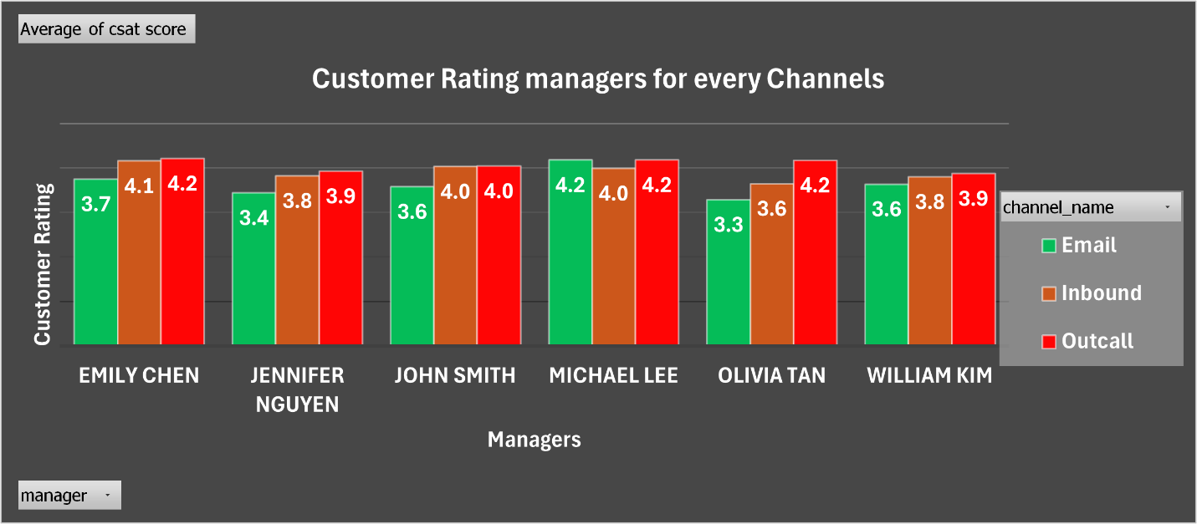

The managers Customer Rating for every channel, if the channels that affect managers work.

The green par chart is (Email) and brown par chart is (Inbound) and red par chart is (Outcall).

The managers' evaluation peaks in the channel (Outcall), it decreases in (Inbound), and there is slump in (Email), except (Michael Lee) the channels (Outcall) and (Email) are equal.

In this graph, there is no difference in the managers’ evaluation of each channel, as they are all approximately equal.

**2-Do the prices of products affect customer service on managers?**

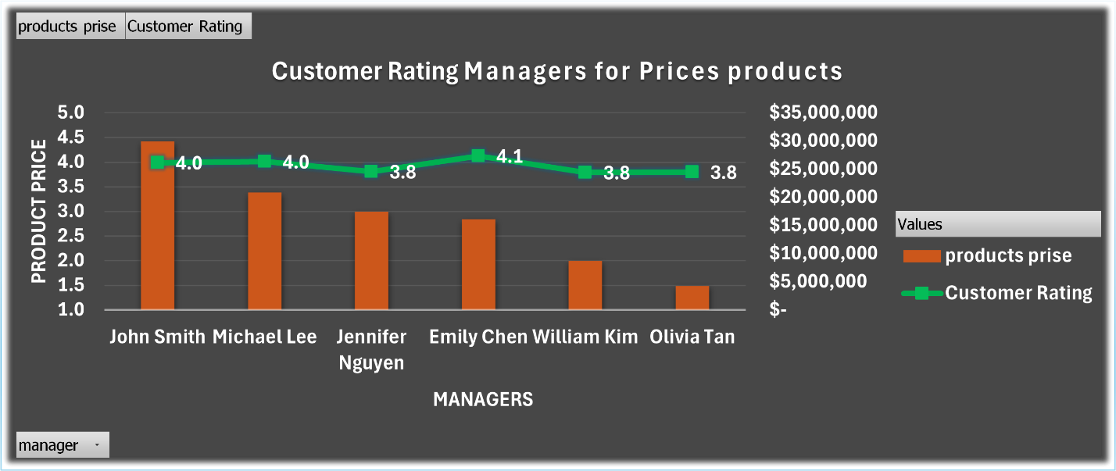

The managers product price and the Customer Rating, if the price that effect in the managers Customer Rating.

The green par chart is the product price, and the line chart is the Customer Rating for the managers.

1. With an approximate "Sum of price" of $30 million, John Smith has the greatest price, but his "Customer Rating" is very low at 4.0.
2. At over $20 million, Michael Lee has the second highest "Sum of price" and the highest "Average of Customer Rating" (4.1).
3. Jennifer Nguyen's "Customer Rating" is 3.8, while her "Sum of price" is approximately $18 million.
4. With an estimated $17 million, Emily Chen has the lowest "Sum of price" yet the greatest "Customer Rating" (4.2).
5. William Kim has an "Customer Rating" of 3.8 and a "Sum of price" of almost $7 million.
6. Olivia Tan has an "Customer Rating" of 3.8 and a "Sum of price" of almost $4 million.

**3-How many orders for each Customer Rating do they get?**

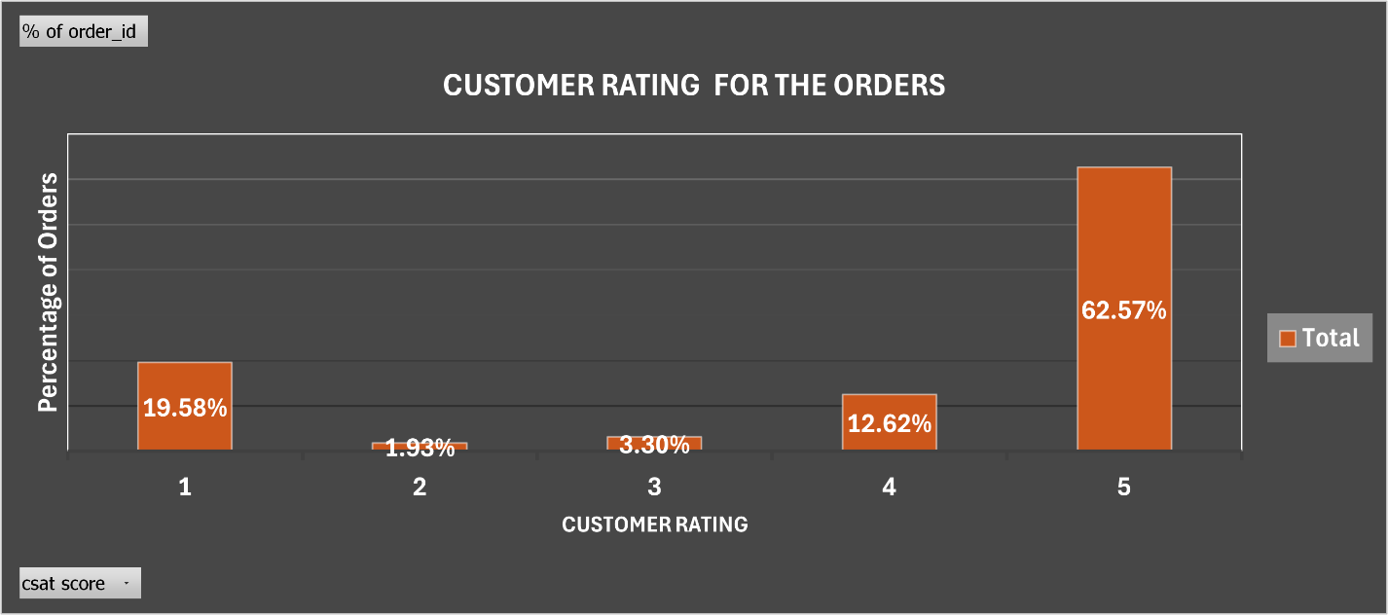

The graph shows a bar chart of the percentage of orders in every Customer Rating.

1. The percentage of orders (19.58%) in a Customer Rating of 1.
2. The decreased percentage of orders (1.93%) in a Customer Rating of 2.
3. The increased percentage of orders (3.30%) in a Customer Rating of 3.
4. The increased percentage of orders (12.62%) in a Customer Rating of 4.
5. The highest percentage of orders (62.57%) have a Customer Rating of 5.

while a significant percentage of orders get the maximum Customer Rating of 5, a many of them still have a relatively low rating of 1.

**4-What is the Customer Rating of the problems that take the longest time to solving problems**

The graph shows the Average of age_daytime by DAY and " Customer Rating " for different types of problems.

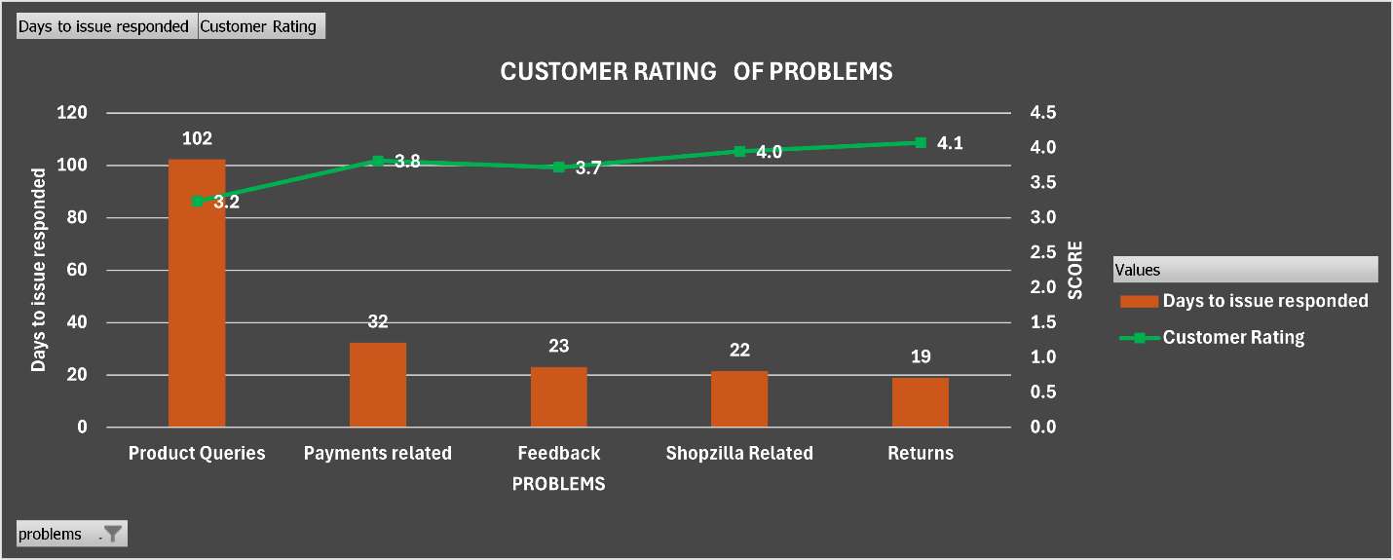

1. (Product queries) had the lowest "Customer Rating" (3.2) and the greatest "Average of age daytime" (102 days).
2. With an Average of age daytime Decreased to (32 days) and increased a Customer Rating of (3.8), (payments related) problem rank second
3. Decreased in The Customer Rating for (feedback) concerns is (3.7), while the Average of age daytime is Decreased to (23 days).
4. Decreased The Average of age daytime for (Shopzilla Related) problems is (22 days), while the Customer Rating is increased (4.0).
5. increased With a Customer Rating of (4.1) and Decreased an Average of age daytime of (19 days), (Returns) have the lowest averages.

the graph shows that as the "Days to issue responded" decreases, the customer rating tends to increase.

**5-What is the rate of the sub problem for the top 3 problems that take the longest time**

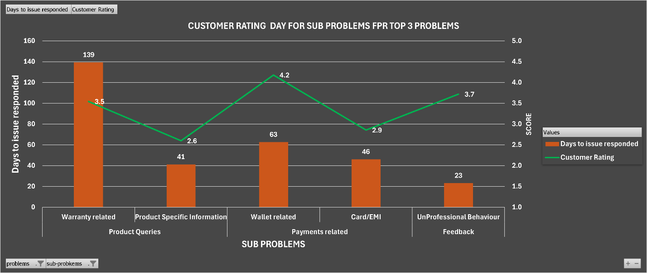

The graph shows sub problems for top 3 problems tack a time to solve, and to Customer Rating for every show sub problems.

1. Sub problems in (Product Queries) problem is Warranty related with higher days (139 Days) and Customer Rating is (3.5)

And second Product Specific Information with (41Days) and Customer Rating is (2.6)

1. Sub problems in (Product Queries) problem Wallet related second higher days (63 Days) and Customer Rating is (4.2)

And second Card/EMI with (46Days) and Customer Rating is (2.9)

1. Sub problems in (Feedback) has only one is Unprofessional Behavior with (23Day) and Customer Rating is (3.7)

The customer rating and response time (by days) for the subproblems under the "TOP 3 PROBLEMS" are broken out in detail in the graph.

**6-How does the scheduling of shift periods impact employees**

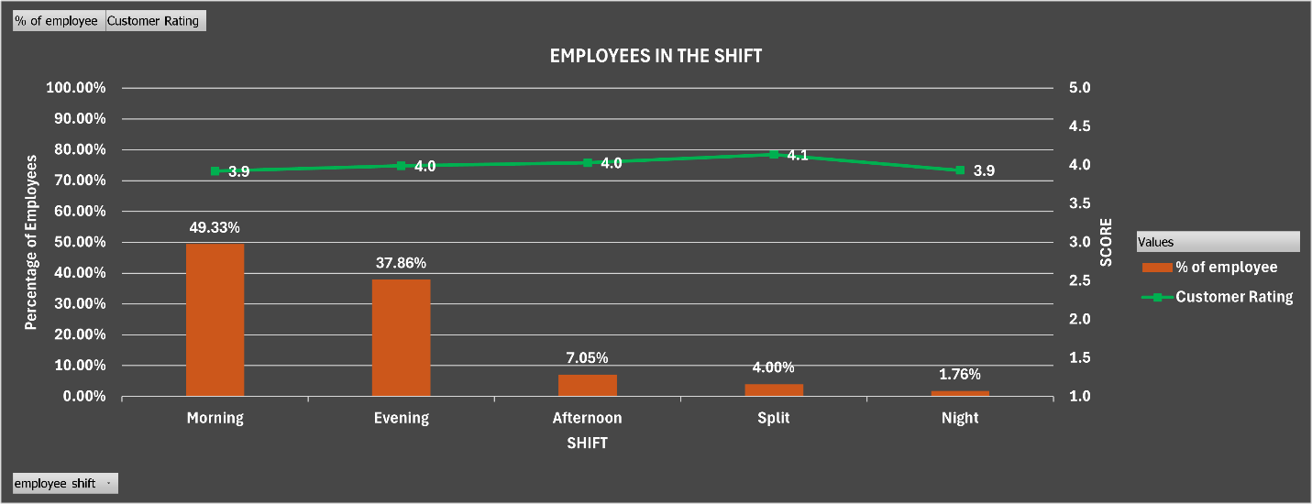

This graph shows the percentage of employees in green and the Customer Rating for the Shifts.

1. With (49.33%) of workers, the morning shift has the highest percentage and average customer satisfaction Customer Rating (3.9).
2. The percentage of workers on the evening shift decreased (37.86%) decreases, and their average customer satisfaction Customer Rating was (4.0).
3. With decreased percentage of workers to (7.05%) on afternoon shift, and the average customer satisfaction Customer Rating Stable (4.0).
4. There is decrease (4.00%) of workers in the “split” shift, and their average customer satisfaction Customer Rating is Increased (4.1).
5. With a decrease (1.76%) of workers, the night shift has the lowest percentage of employees but maintains an average customer satisfaction Customer Rating Stable (4.1).

morning and evening) have slightly lower average customer satisfaction Customer Rating than shifts (afternoon, split, night)

**7-The impact of the tenure bucket (employees’ insurance) on employees**

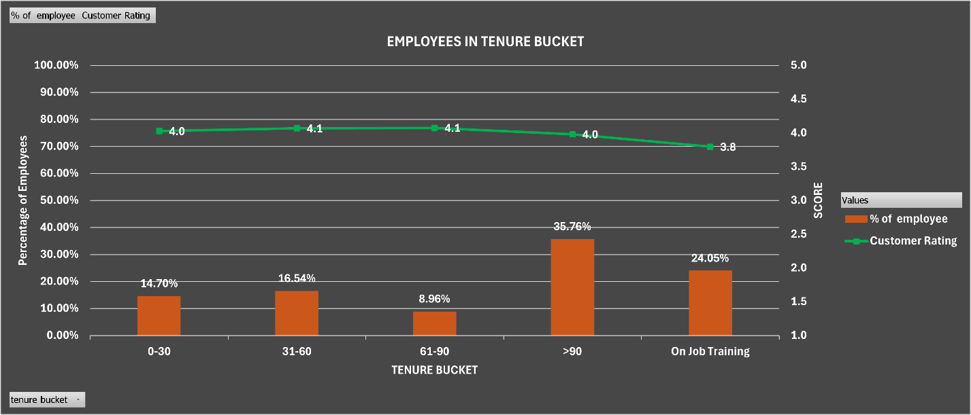

1. At (35.76%), employees with more than (90) days of tenure bucket had the largest percentage and an average customer satisfaction Customer Rating of 4.0.
2. The number of employees decreased to (24.05%) of workers in the "On-the-job training" tenure bucket, and their average customer satisfaction Customer Rating decreased to (3.8).
3. Employees with (31 to 60) days represented a decrease in the number of employees by (16.54%) of the workforce, and they had a high average customer satisfaction Customer Rating of (4.1).
4. The percentage of workers with (0 to 30) days decreased by (14.70%), and their average customer satisfaction Customer Rating decreased to (4.0).
5. The smallest portion of the number of employees had (61 to 90) days at (8.96%), and their average customer satisfaction Customer Rating was low (3.8).

**8-How many employees for every Customer Rating in employee shift**

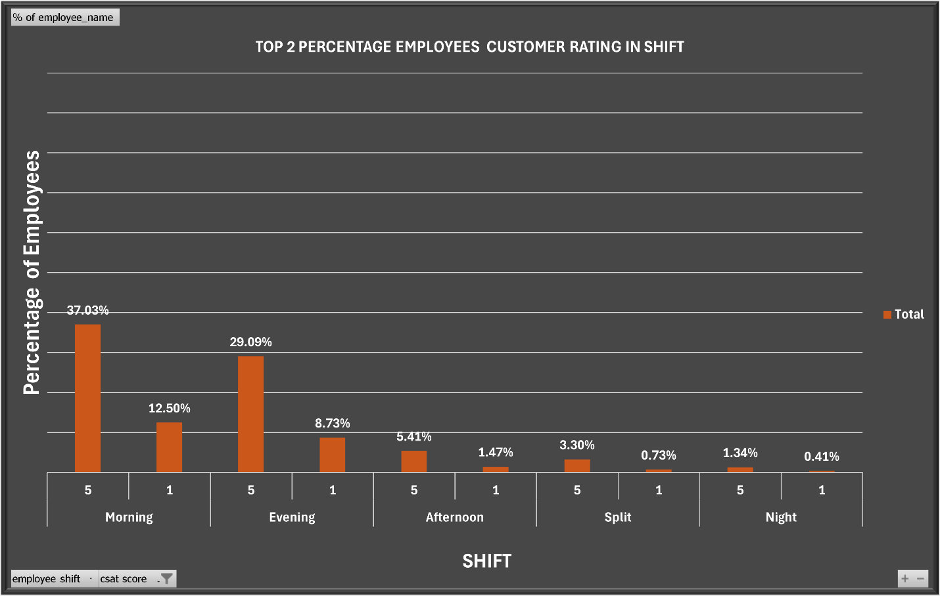

this graph shows percentage of employees in top 2 Customer Rating in shits

1. morning shift highest 2 Customer Rating in 1 with (12.5%) and increase Customer Rating in 5 (37%)
2. Evening shift highest 2 Customer Rating in 1 with (8.7%) and increase Customer Rating in 5 (29%)
3. Afternoon shift highest 2 Customer Rating in 1 with (1.4%) and increase Customer Rating in 5 (5.41%)
4. morning shift Split 2 Customer Rating in 1 with (0.7%) and increase Customer Rating in 5 (3.3%)
5. morning Night highest 2 Customer Rating in 1 with (1.3%) and increase Customer Rating in 5 (0.4%)

(Morning and evening) shifts have the highest number of top performers, while (night) shifts have the lowest number of top performers.

**9-How many employees for every Customer Rating in tenure bucket (employees’ insurance)**



1. tenure Bucket (>90) highest 2 Customer Rating in 1 with (8.4%) and increase Customer Rating in 5 (27.6%)
2. tenure Bucket (on job training) highest 2 Customer Rating in 1 with (6.9%) and increase Customer Rating in 5 (17%)
3. tenure Bucket (31-60) highest 2 Customer Rating in 1 with (3.4%) and increase Customer Rating in 5 (12.9%)
4. tenure Bucket (0-30) highest 2 Customer Rating in 1 with (3.2%) and increase Customer Rating in 5 (11.4%)
5. tenure Bucket (61-90) highest 2 Customer Rating in 1 with (1.8%) and increase Customer Rating in 5 (7.11%)

Employees with longer tenures (>90, 31-60) have higher performance than those with shorter tenures (0-30, 61-90). The “on-the-job training” category also has a relatively high proportion of top performers.

**5.conclusion:**

1. **Enhance employee performance by implementing policies that promote longer tenures, thereby allowing employees to gain deeper expertise and contribute more effectively to the organization.**
2. **Optimize shift scheduling to assign employees to shifts that align with their productivity patterns. According to the analysis, productivity is higher during the afternoon and split shifts. Thus, accommodating these preferences could improve overall efficiency.**
3. **Prioritize resolving issues that require extended durations and strive to provide customers with comprehensive product information more swiftly. This approach will enhance service efficiency and customer satisfaction.**

**6.Recommendation:**

1. Enhance employee performance by implementing policies that promote longer tenures
2. Optimize shift scheduling to align with productivity patterns
3. Give addressing problems that take a long time priority.